Population Ecology

Mark and Recapture
Mr. Pascoe led a green sea turtle population study along the southern shore of Anegada. His team completed the data table below while they conducted a Mark and Recapture study. Use the formula to estimate the population size of green sea turtles on the southern flats of Anegada.
Trial | Captured | Recaptured | Marked and Recaptured | Population Estimate
1 | 23 | 18 | 5
2 | 30 | 23 | 7
3 | 19 | 22 | 6

What is the average population estimate?

Sampling
To determine the population of Aspen trees in a section of Rocky Mountiain National Park in Colorado, Meg and her team counted the number of Aspens in a relatively small area. Then, they used multiplication to estimate the number of Aspen in a larger area. Their data is below, depicting the number of Aspen they counted in three different 100 square meter areas. How many Aspen might be expected within one square kilometer?
Area | Number of Aspen
A | 32
B | 26
C | 28

Sampling: Challenge
Mosquito larvae were found in Amanda’s plant container. I took three 10ml samples of the standing water and counted 6, 8 and 9 larvae. Amanda’s plant container is a cylinder, and there were 5cm of water in it. Use the formula to find the volume of water contained in the cylinder and use it to estimate the total population of mosquito larvae living within.

Graphing Changes in Populations
Complete the table of Wolf and Deer populations below. Then, graph the information in the provided space. Use a different color on your line graph for the populations of wolves and deer.
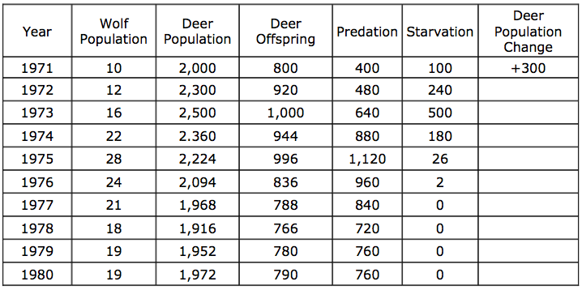

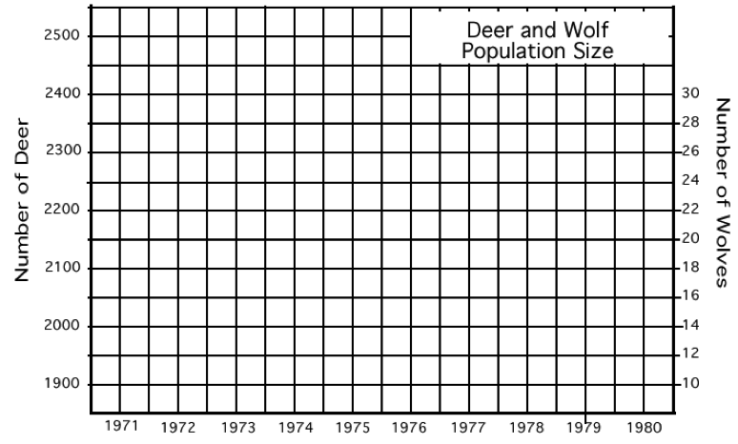

Changes in Populations: Challenge
In a small pond, populations of tadpoles, mosquito larvae and dragonfly larvae interact with each other. Originally, 3,000 mosquito larvae hatched at the same time as 150 tadpoles emerged from their eggs looking for a meal and 15 dragonfly larvae reached a size where they could begin preying upon the tadpoles.
-Each day, a tadpole must prey upon 10 mosquito larvae to stay alive.
-Each day, a dragonfly larva must prey upon 6 tadpoles to stay alive.
-Each day, 2,000 more mosquito larvae hatch.
-Each day, 80 more tadpoles emerge from their eggs.
-Each day, 8 more dragonfly larvae reach the right size.
1. Simulate the interactions between these populations for 7 days in the data table below.
2. Create three line graphs:
Graph 1: Populations of Dragonfly Larvae vs Tadpoles over 7 days.
Graph 2: Populations of Mosquito Larvae vs Tadpoles over 7 days.
Graph 3: Populations of Dragonfly larvae vs Mosquito Larvae over 7 days.

3. Answer the following questions in complete sentences.
A. Analyze the populations of the tadpoles, mosquito larvae and dragonfly larvae. Are the interactions between these populations sustainable? Can you make a prediction about what might happen to these populations in the future? (Will the mosquito larvae population collapse? Etc) Does one population seem to be acting as a limiting factor for any of the others during any point of the simulation?
B. This small pond contains 800L of water. What is the population density of each of these organisms at the end of the 7 day simulation?

Populations Data Table
Organism |  | Day 1 | Day 2 | Day 3 | Day 4 | Day 5 | Day 6 | Day 7
Mosquito Larvae | Starting Population  Predations\Deaths  Births  Ending Population | 3,000
 |  | 2,000
Tadpoles | Starting Population  Predations\Deaths  Births  Ending Population | 150
 |  | 80
Dragonfly Larvae | Starting Population  Predations\Deaths  Births  Ending Population | 15
 |  | 8

